SENG305

Term Project

**Traffic Monitoring**

|  |  |  |  |
| --- | --- | --- | --- |
| **Tasks of the project** | **Roles** | **Student Numbers** | **Names** |
| Role, stakeH. PG, OG | 1 | 22146406 | PECULIAR TOLUWANI ABE |
| Requirement | 22146406 | PECULIAR TOLUWANI ABE |
| Use case diagram | 2 | 22120890 | ÖMER ÇAĞLAR GÖK |
| ArchStyle | 22120890 | ÖMER ÇAĞLAR GÖK |
| 3 scnario | 3 | 22120888 | SELİN ÖZDURAN |
| 3 sequence diag | 22120888 | SELİN ÖZDURAN |
| Context diag | 4 | 22141071 | MELANIYA DMITRIYENKO |
| DFD | 22141071 | MELANIYA DMITRIYENKO |
| User Interface des | 5 | 21148013 | SAID HAIDAR SAID JABER |
| Consistency | 6(contact person) | 22143045 | NAHID LALÁ DAÚDE |
| Trackıng | 22143045 | NAHID LALÁ DAÚDE |

**Requirements Analysis**

**Title Of The Project:**

Traffic Monitoring

**Project Description** : This project aims to provide helpful information about traffic in a given geographic area based on the history of traffic patterns, current weather, and time of the day. Such information can be used by automobile drivers in choosing the best time to travel a given route or the best route at a given time.Most traffic information services (e.g., Yahoo! Traffic, Traffic.com) only provides current information about traffic conditions in a given area. While current information is essential, these reports are often incomplete because their sources frequently fail to report the current traffic conditions. Hence, the user cannot assume that there is no heavy traffic in a given location simply because that location was not reported by these services. The idea is to analyze historical traffic information collected over a long period of time to highlight locations which appear most frequently in the traffic advisories and thus are likely to be subject to heavy traffic conditions even if they do not appear in the current traffic advisory.

Here are type of services that could be offered by building this :

• A “traffic map” which reviews historic traffic “hotspots” across a certain area, given the

choice of day(s) of the week, weather conditions, and severity of incidents

• Historic traffic patterns along a path (route) between two end-points, given time of the

day and weather conditions

• If the desired route is anticipated to suffer heavy traffic for the specified travel period, the

system could suggest an alternative period to travel along the current route.

**Responsibilities:** As the individual responsible for requirements analysis my primary role includes:

* Gathering and defining system requirements such as user, system, functional, non-functional, and constraints
* Ensuring clarity and consistency in requirements to avoid ambiguities.

**Requirements Analysis**

1. Stakeholders such as drivers would be seeking real-time and historic traffic insights, while system administrators would maintain the system and ensure data accuracy . Data providers (government agencies or third-party APIs) are also important because they are the sources for providing traffic and weather data and lastly software engineers would be responsible for developing and maintaining the system.

2. Organizational and Project Goals : The organizational goals would practically be to Improve the safety on the road by providing traffic insights while for the project goals we are to develop a system that provides previous traffic pattern analysis, real-time traffic forecasts, and better route optimization suggestions.

3. **Requirements** : This would include both functional requirement and non functional requirement of the system

**Functional Requirements**

* The system would provide a map of previous traffic hot spots based on the selected day(s), weather conditions, and severity levels.
* The system would also break down past traffic patterns for routes between two points.
* The system would likewise suggest an alternative travel time so that the user can maneuver heavy traffic if it is anticipated.
* The system would allow users to input start and end points, desired travel time, and weather conditions for analysis.

**Non-Functional Requirements**

* The system would respond to user requests within 2 seconds.
* The user interface shall be accessible on desktop and mobile platforms.
* The system would ensure data privacy and security in accordance with GDPR.

**Constraints**

* The system must integrate with third-party APIs for traffic and weather data.
* The system shall support a maximum of 100,000 concurrent users.
* Data storage for historical patterns shall be limited to the past 5 years.

**Scenarios**

**Scenario 1: Traffic Hotspot Map Generation**

* **Aim:**  Help users visualize areas frequently impacted by traffic incidents under specific conditions.
* **Actors:** Driver (primary), System (provider,secondary)
* **Necessary Conditions:**
* Historical traffic data is available.
* The user is logged in to the system.
* **Steps:**
  + The user navigates to the “Traffic Hotspot Map” feature.
  + The user inputs:
    - Location (e.g., city or neighborhood).
    - Specific days of the week
    - Weather conditions (e.g., sunny, rainy).
    - Severity levels (e.g., minor or severe).
  + The system analyzes historical data and generates a heatmap of frequent traffic hotspots.
  + The system displays the heatmap and provides analysis.
  + The user views the visual representation and identifies regions to avoid during travel.
* **Result:** The user obtains actionable insights about heavy traffic or traffic prone areas based on the entered location and weather conditions.

**Scenario 2: Route Based Traffic Pattern Analysis**

* **Aim:** Offer detailed analysis and suggestions for a specific route.
* **Actors:** Driver (primary), System (provider,secondary)
* **Neccerary conditions:**
* Historic traffic data is available.
* The user is logged in to the system.
* **Steps:**
  1. The user selects the "Route Analysis" feature.
  2. The user inputs:
     + Start and end points.(e.g neighborhood or address)
     + Desired travel period and forecasted weather conditions.
  3. The system analyzes historical data to provide:
     + Traffic patterns for the given route.
     + Expected traffic density at various times of the day.
     + Weather impact on traffic flow.
  4. The system displays the route analysis.
  5. The user reviews the insights and adjusts travel plans accordingly.
* **Result:** The user chooses the best fit route in the given time.

**Scenario 3: Predictive Travel Assistance**

* **Aim:** Notify users of anticipated heavy traffic and suggest alternatives.
* **Actors:** Driver (primary), System(provider,secondary)
* **Necessary conditions:**
* Historic traffic data is available.
* The user is logged in to the system.
* The user has configured notification preferences.
* **Steps:**
  1. The user schedules a trip by input:
     + Start and end points of the route.
     + Planned time and weather forecast.
  2. The system forecasts traffic conditions using historical data.
  3. If heavy traffic is likely, the system:
     + Sends a notification to the user (e.g., via mobile or email).
     + Displays the route and heavy traffic.
     + Provides detour options or alternative travel times.
  4. The user chooses an alternative route.
* **Result**: Based on the predicted traffic conditions and system notification the user avoids delays.

**Use Case Scenario**

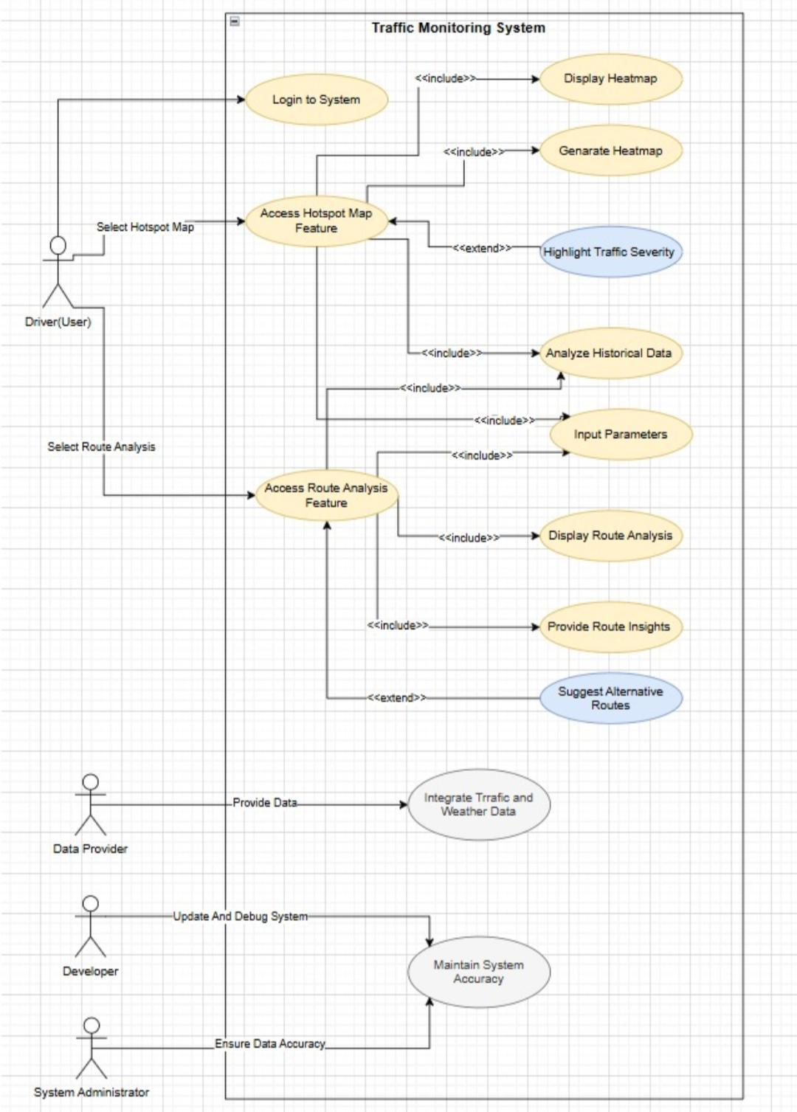

**Context diagram**

As defined above through requirements and scenarios, the “Traffic Map System” provides basic user support functions and processes that we can illustrate in detail and understandably through the context diagram, such as:

-Receive the necessary request from the user;

-Obtain the necessary data from external information sources through enquiry;

-Collect and analyze the received data;

-Demonstrate the result to the user by analyzing their query and available data.

Historic traffic hotspots map

Weather conditions

Travel time

Start-end points

Traffic data

Weather data

Enquiry for data

data validation

System status report

System reports

system state

feedback

System updates

Enquiry

route optimization suggestions

Traffic forecasts

Developer

User

**Traffic Map System**

**Traffic Map System**

System status monitoring

System

admin

Data

providers

Once the Context Diagram is clearly defined and we know the underlying system and its main sources of operation, we can move on to Data Flow Diagrams for a deeper understanding of the structure.

**Data Flow Diagrams**

**Level 0: The basic process of receiving data and analyzing it in the system**

Suggesting an alternative or better way

Developer

route analyses

map of historic traffic hotspots

User

Analyzed solutions

Weather conditions

2.0

Suggestions

Travel time

Start-end points

forecasts

Enquiry

Processing and analyzing the obtained data

Generation of the result and sending it to the user

3.0

1.0

Receiving data from user

User inputs

5 years traffic data

Traffic conditions

Weather conditions

System condition

User inputs

User enquiries and data store

Historical traffic data store

performance and bug reports

Current time conditions data store

Traffic data

Data

providers

Weather data

System

admin

The Level 0 diagram contains the main and basic processes of the system that take in information, process it, and convert it into an output for the user. The main processes of the diagram can be divided into the following sub-processes shown in the diagrams of the next level.

**Level 1: Main sub-processes in “Processing and analyzing the obtained data”**

User inputs

User enquiries and data store

User inputs

Formed results

Receiving data for analysis

2.1

route analyses

User inputs

2.3

map of historic traffic hotspots

Alternative or better way

User inputs

Route Traffic Pattern Analysis

Analyzed results generation

2.5

Analysis and suggestions

Historical traffic data store

Current time conditions data store

2.2

Hotspot map Generation

Anticipated heavy traffic

Suggestion of alternative ways

Predictive Travel Assistance

2.4

Formed traffic hotspots and their analysis

This diagram shows the main sub-processes from the ‘Processing and analyzing the obtained data’ process, which process the obtained information and transform it into the required functional results, which show the user all the necessary parameters and suggest the best ways to solve the problem.

**Level 2: Traffic hotspot map generation**

User enquiries and data store

2.2.2

User input parameters

Obtained inputs

Fully analyzed data and traffic data

Analyzing historical, conditions and user data

2.2.1

Obtaining user data

5 years traffic data

2.2.3

Generation of heatmap

Historical traffic data store

All analysis

2.2.4

Forming and sending the generated result

Generated heatmap

Visual representation

Formed results

**Level 2: Route based traffic pattern analysis**

User enquiries and data store

User input parameters

2.3.3

Analyzing route patterns

2.3.2

Obtained inputs

Generation of route information

2.3.1

Obtaining user data

Traffic patterns for given route

Weather impact

Fully analyzed data and traffic data

Traffic density

5 years traffic data

2.3.4

Forming and sending the generated result

Route analysis

Historical traffic data store

Insights

Formed results

**Level 2: Predictive travel assistance**

User enquiries and data store

User input parameters

Formed forecasts

Formed forecasts

2.4.2

Analyzing and forming traffic forecasts

Obtained inputs

2.4.3

Obtaining user data

2.4.1

Creating and sending notifications

Formed forecasts

5 years traffic data

Notifications

Historical traffic data store

Defining the route and heavy traffic

2.4.5

2.4.4

Alternatives

Heavy traffic

Defining and providing alternatives

Route

Formed results

In the three level 2 diagrams, 3 important sub-processes have been identified that perform the main functions and provide the result to the user.

Now all the main functions and processes of the system are defined in diagrams and are clearly understandable for both developers and stakeholders.

**User** **Traffic Map System** **Weather Data Provider Traffic Data Provider**

**Sequence Diagram 1**

Request Weather Data

Request Traffic Data

Provide Traffic Data

Request Traffic Hotspot Map

Request Inputs (Area, Days)

Provide Inputs

Display Hotspot Heatmap

Provide Weather Data

USER

**Weather Data Provider**

**Traffic Map System**

**User**

**Traffic Data Provider**

Request Route Analysis

Request Weather Data

Request start and end points

Provide Weather Data

Provide start and end points

Request Traffic Data

Suggest alternative routes and travel times

Provide Traffic Data

**Sequence Diagram 2**

**Sequence Diagram 3**

Request Traffic Predictions

Provide Traffic Predictions

Notify Traffic Issues and Suggestions

Provide Weather Forecast

Request Weather Forecast

Request Schedule Trip

**Traffic Data Provider**

**Traffic Map System**

**User**

**Weather Data Provider**

**ArchStyle**

LAYERED SYSTEMS

Layered systems use a hierarchical client-server model

Each layer provides an API for layers above, acting as both server client.

In the Traffic Monitoring System, the modular nature of this architecture ensures that changes to one layer will not directly affect others.

Each module is responsible for a specific part of the system, making debugging and updates manageable.

Integration with third-party APIs (e.g., traffic and weather data) can be handled at a specific layer without disrupting the rest of the system.

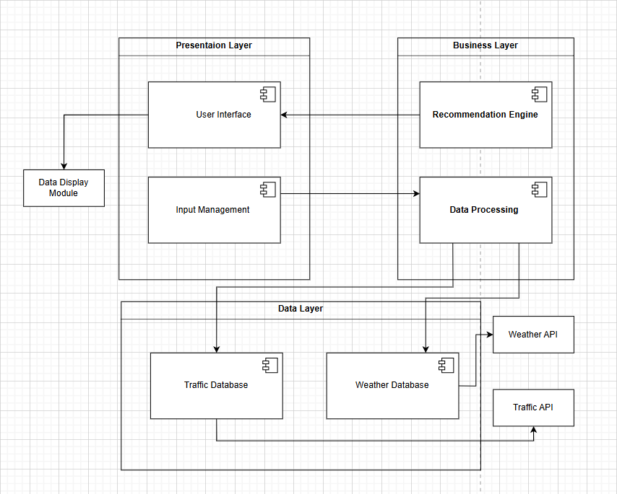

**Presentation Layer;**

User Interface: This includes inputs such as location, weather conditions and travel times.

Input Management: Receives input and passes it to appropriate modules.

Data Display Module: It is a module that visually presents traffic frequent maps and analysis reports to the user.

**Business Layer;**

Data Processing: Processes the data entered by the user and analyzes the data.

Recommendation Engine: Provides alternative routes based on frequent traffic routes and historical weather information.

**Data Layer;**

Traffic Database: Stores historical traffic patterns. Including data about locations, time of day, etc.

Weather Database: Provides support for traffic analysis based on weather conditions.

Weather API: Provides weather data.

Traffic API: Provides real-time data on traffic frequent data.

**User Interface Description**

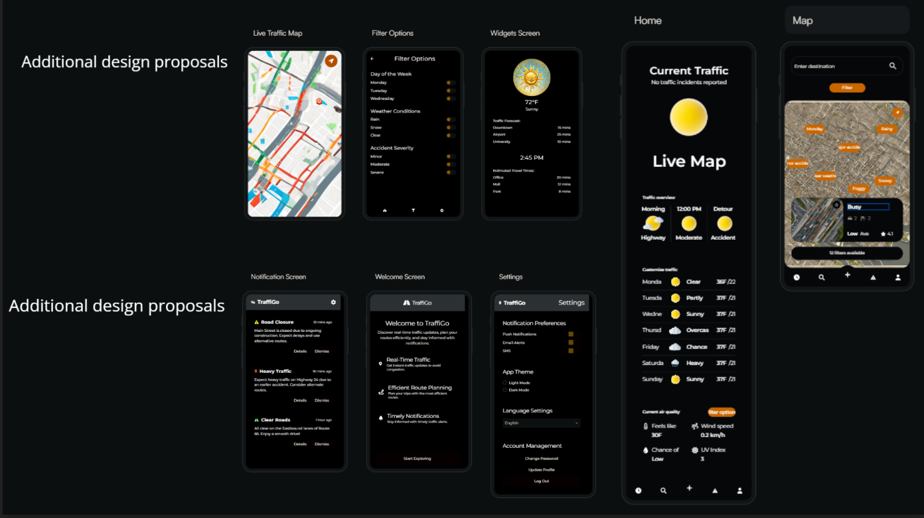

**Tool Screesnhots**

11.12.2024

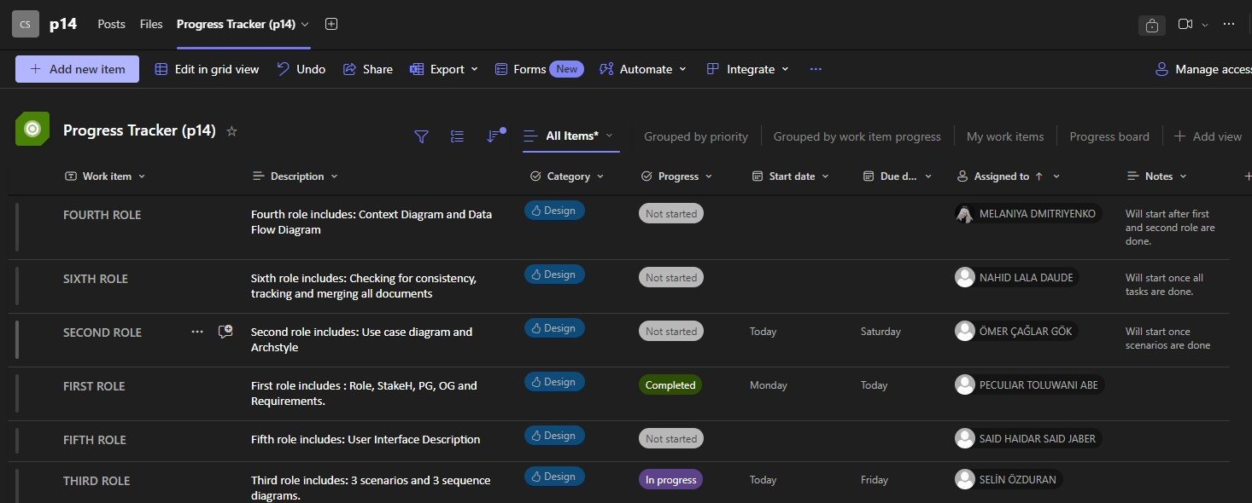

16.12.2024

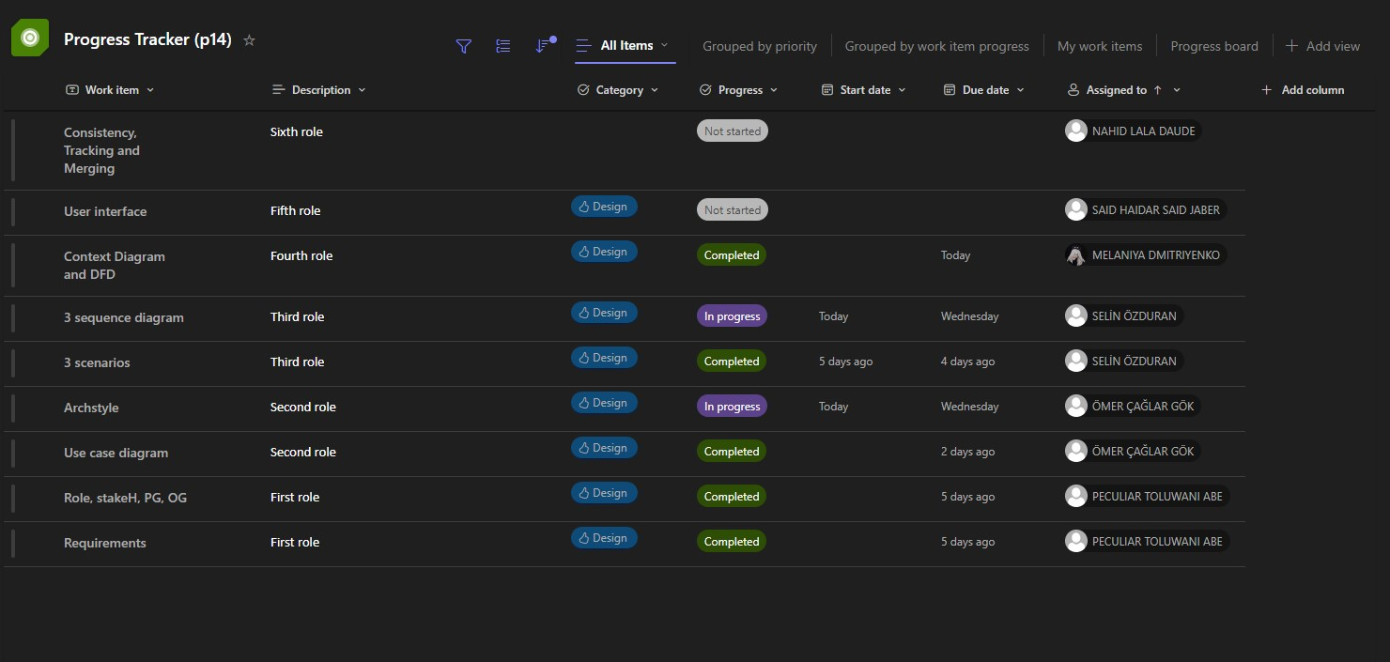

19.12.2024

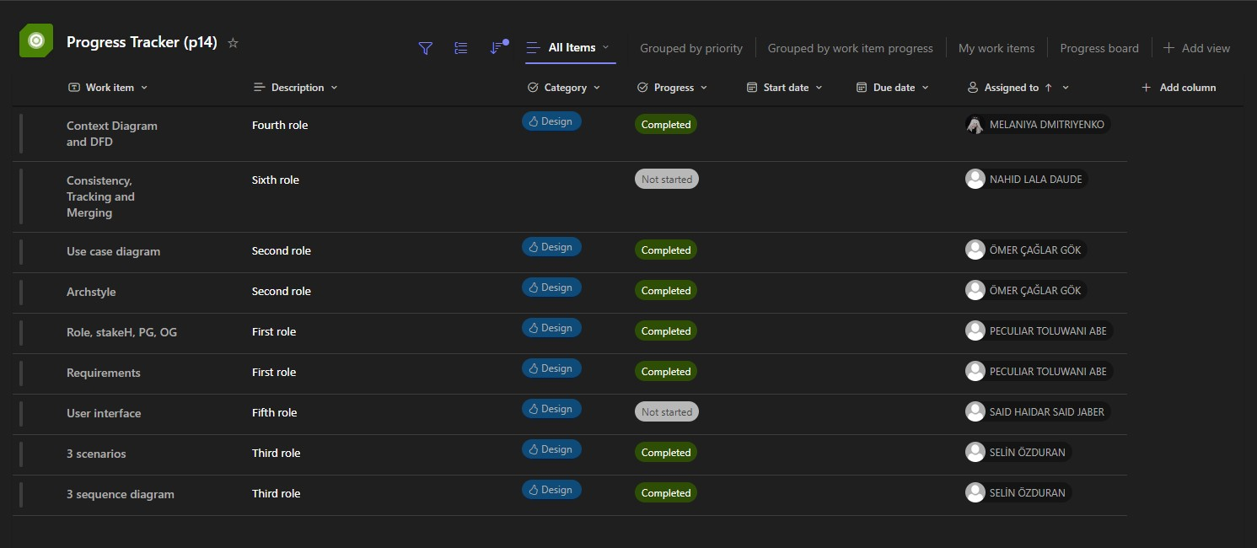

25.12.2024

